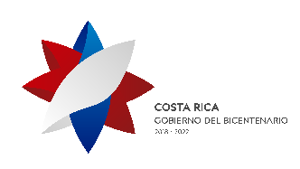

FIFTH MEETING OF THE FORUM OF THE COUNTRIES OF LATIN AMERICA AND THE CARIBBEAN ON SUSTAINABLE DEVELOPMENT

San José, 7–9 March 2022
HOTEL RESERVATION REQUEST
Name |  |  | Surname
Head of delegation | Delegate |  |  |  | Observer | Special guest
Title: |  |  |  |  | Agency:
Address:
City: |  |  |  | Country:
Telephone no: |  | Fax: |  |  | Email:
Hotel information:
HOTEL HILTON SAN JOSE LA SABANA (5*)  Antiguo restaurante El Chicolte Sabana Norte  San José, Costa Rica  Teléfono: +506 2520 6001  Standard single room: US$ 169 plus 13% tax  Standard double room: US$ 179 plus 13% tax  Email: mariela.Chavez@Hilton.com  Enquiries: Mariela Chavez | HOTEL PARK INN By RADISSON  Ave 6-10, Calle 28-30  Barrio Don Bosco  San José, Costa Rica  Teléfono: +506 4110 1100  Standard single room: US$ 109 plus 13% tax  Standard single room: US$ 109 plus 13% tax  Email: zulay.castillo@parkinncostaica.com  Enquiries: Zulay Castillo
- Rates in all hotels include breakfast and Internet

The Hilton hotel provide airport transfers at a cost of US$ 30 per person per trip. These must be arranged directly with the contact person at each hotel.
Date of arrival in Costa Rica: |  | Flight No: | Approx. time:
Date of departure from Costa Rica: |  | Flight No: | Approx. time:
I authorize use of the following credit card to guarantee my hotel reservation:
American Express | Master Card | Visa |  | Other
Card number/security code: |  |  | Expiry date:
Reservation requests should be addressed directly to the hotel no later than 28 February.

